Data Structure and Algorithm

Laboratory Activity No. 5

Implementation of Arrays

|  |  |
| --- | --- |
| *Submitted by:* | *Instructor:* |
| Polestico, Paul Justine D. | Engr. Maria Rizette H. Sayo |

August, 16, 2025

# Objectives

Introduction

Array, in general, refers to an orderly arrangement of data elements. Array is a type of data structure that stores data elements in adjacent locations. Array is considered as linear data structure that stores elements of same data types. Hence, it is also called as a linear homogenous data structure.

This laboratory activity aims to implement the principles and techniques in:

* Writing algorithms using Array data structure
* Writing a python program that can implement Array data structure

# Methods

* Write a Python program to create an array of 10 integers and display the array items. Access individual elements through indexes and compute for the sum.
* Write a Python program to append a new item to the end of the array. Original array: numbers = [1, 2, 3, 4, 5, 6, 7, 8, 9, 10]
* Write a Python program to insert a new item before the second element in an existing array. Original array: numbers = [1, 2, 3, 4, 5, 6, 7, 8, 9, 10]
* Write a Python program to reverse the order of the items in the array. Original array: numbers = [5, 4, 3, 2, 1]

Write a Python program to get the length of the array. Original array: numbers = [5, 4, 3, 2, 1]

# Results

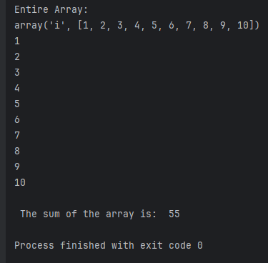

Figure 1 Screenshot of program

**This program creates an array with 10 integers,displays them in a list and by each index, and computes the sum of the original array.**

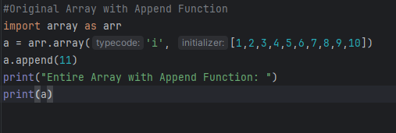

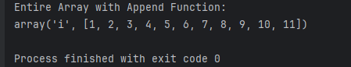

Figure 2 Screenshot of program

**This program adds another element by appending the array with a new index,extending the list by one index.**

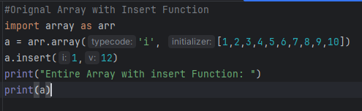

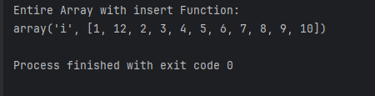

Figure 3 Screenshot of program

**This program uses the insert function to insert a new variable before the second index.**

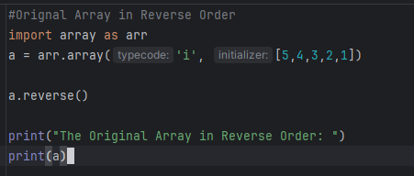

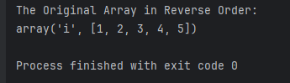

Figure 4 Screenshot of program

**This program uses the reverse function to arrange the order of the array in reverse. The 5,4,3,2,1 array becomes 1,2,3,4,5 because it iterates each element in reverse order.**

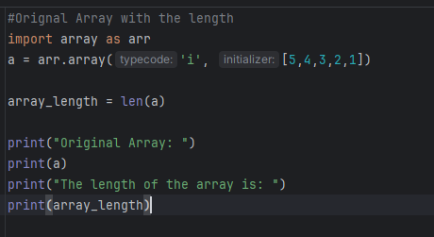

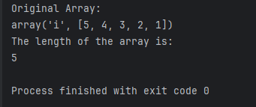

Figure 5 Screenshot of program

**The length function counts the amount of elements in an array by iterating each one by its index until the last one.**

Conclusion

These functions are used not just in processing,storing,and arranging data. They are also used in the real world to manage data efficiently and accurately with reduced time and resource consumption.

**References**

[1] Co Arthur O.. “University of Caloocan City Computer Engineering Department Honor Code,” UCC-CpE Departmental Policies, 2020.

[2] GeeksforGeeks, “Python Arrays,” *GeeksforGeeks*, Jul. 28, 2025. <https://www.geeksforgeeks.org/python/python-arrays/> (Accessed August 16,2025)

[3] GeeksforGeeks, “Python Access Array item,” *GeeksforGeeks*, Jul. 23, 2025. <https://www.geeksforgeeks.org/python/python-access-array-item/> (Accessed August 16,2025)

[4] P. Kumar, “Python Array Add: How to Append, Extend & Insert Elements,” Apr. 15, 2025. <https://www.digitalocean.com/community/tutorials/python-add-to-array> (Accessed August 16,2025)